**EAST WEST UNIVERSITY**

***Big Data Analysis***

**Course Code:** CSE **488**

**Section**: **01**

**Lab Assignment-****6**

**SUBMITTED TO:**

**Name:** Mohammad Rezwanul Huq

**SUBMITTED BY:**

**Name:** MD. WAHIDUZZAMAN

**ID No:** **2019-2-60-048**

**We will have to create a new project in Eclipse.**

Firstly, we will copy the **training** project and then we will rename the project to PageCountS .

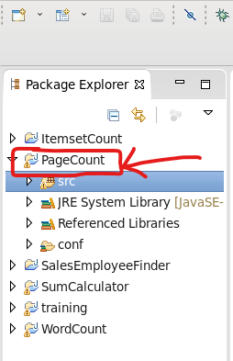

**Figure 1:** Creating a new project named “ItemsetCount”

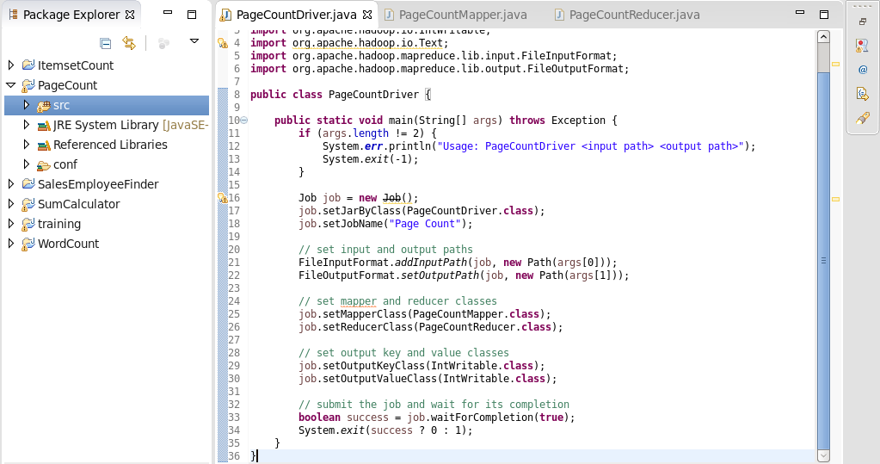

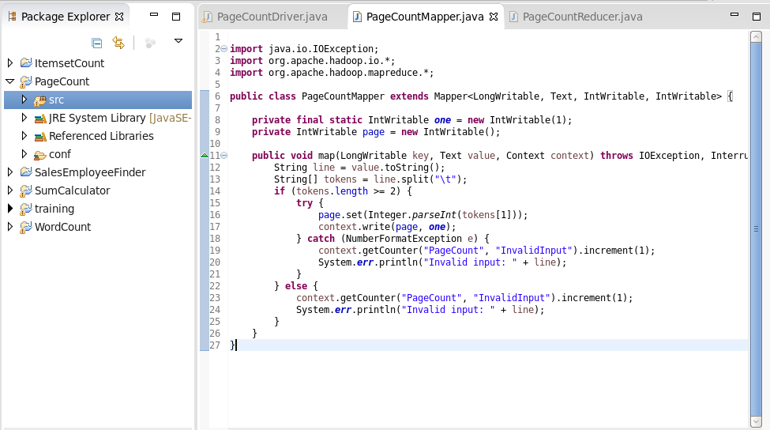

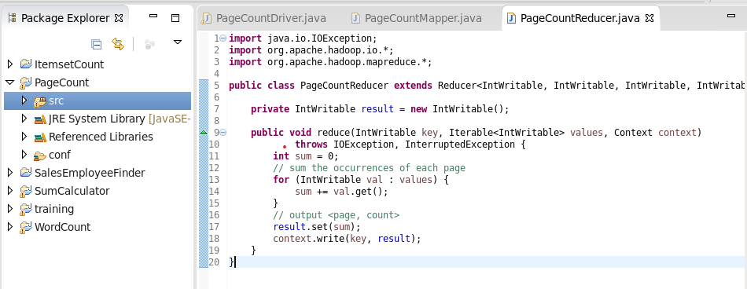

**Figure 2:** implanting code into specific file

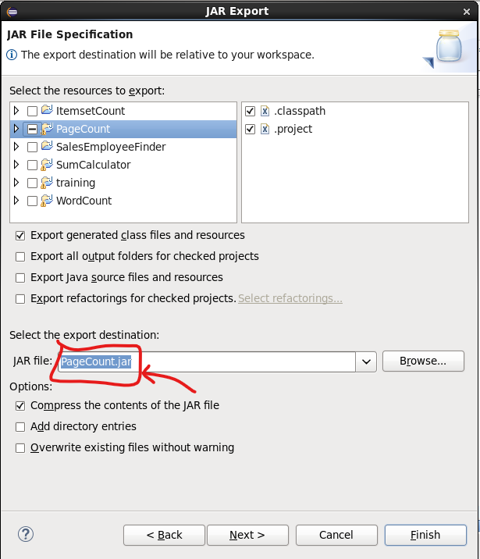

**Figure 3:** Generating jar file of the project

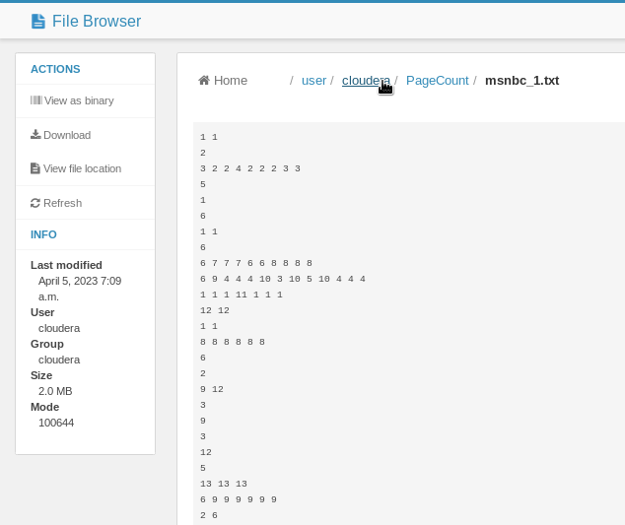

**Figure 4:** Creating new directory and new CVS file

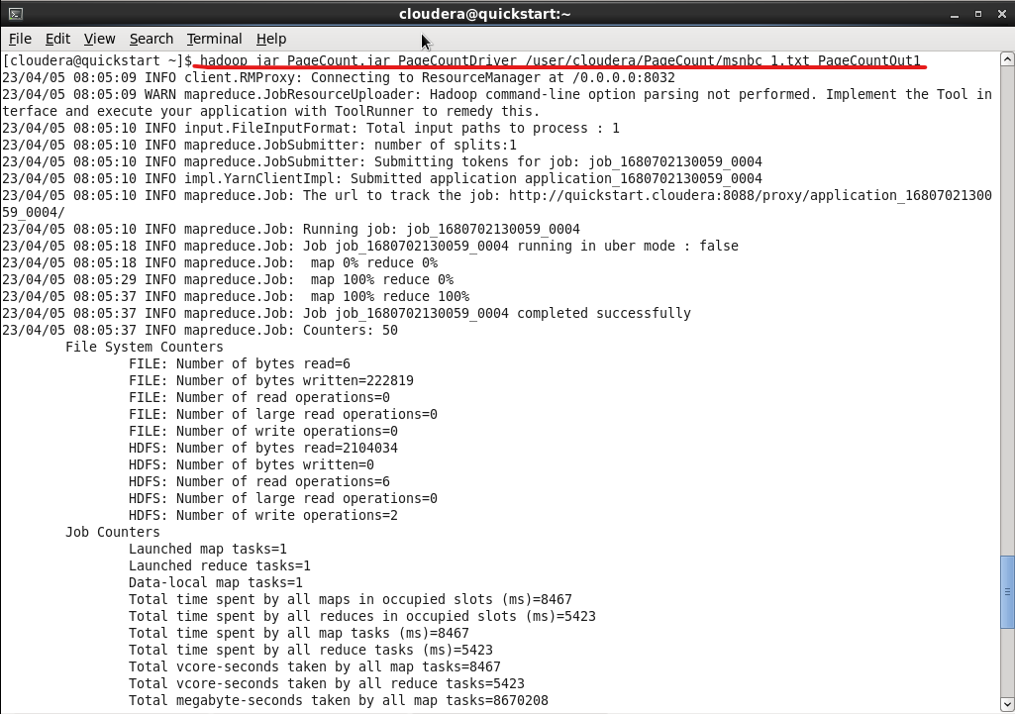

**Figure 5:** Entering the command “hadoop jar <jar file> <main class> <input path> <output path>”

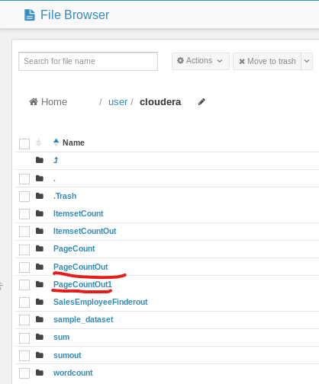

**Figure 6:** Output file successfully generated

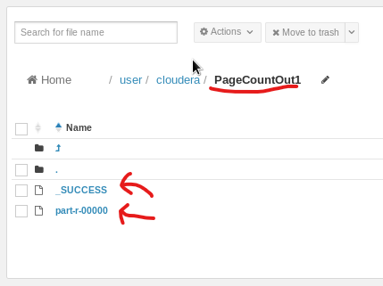

**Figure 7:** The result is showing successfully

**Question 2:**

We will have to change the driver code like this.

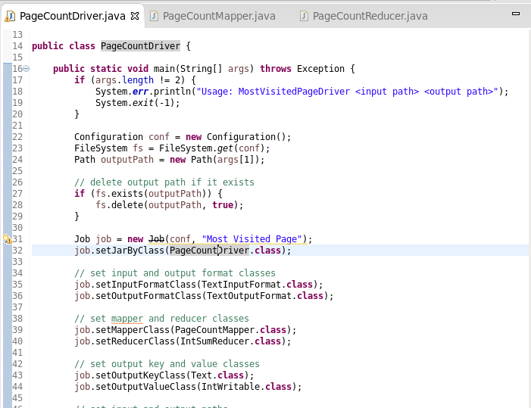

**Question 3:**

We will have to change the Mapper and Reducer code like this.

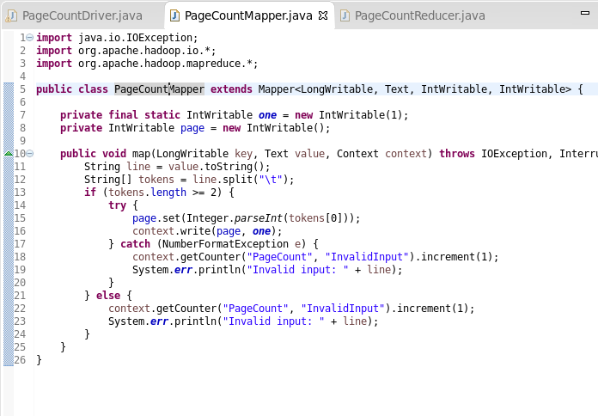

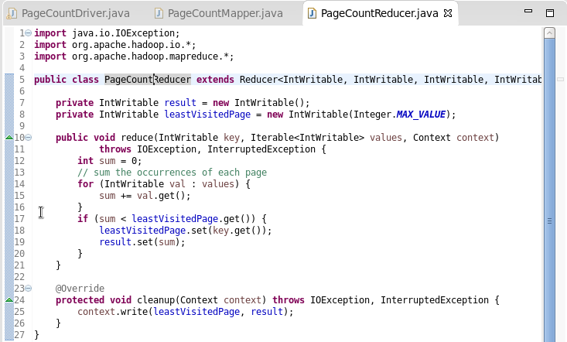

**Question 4:**

We will have to change the Mapper and Reducer code like this.

